Thursday, August 16, 2012

The silent ethnicide. The demise of the rural Italian economy
by FoodFIRST·Thu, 1970-01-01

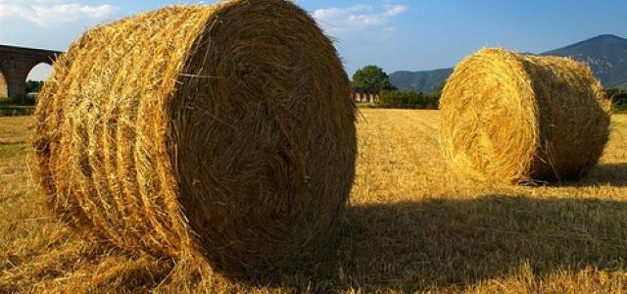
As a continuation of the foodFIRST debate on food and sustainability (FoodFIRST Floriade conference in Venlo, The Netherlands - www.foodfirst.eu), the SID Forum has invited the Italian anthropologist Michela Zucca, to provide a picture of what the Italian rural environment and rural life look like today. Italy used to be one of the top agricultural producers and exporter country of high quality refined products. Today the country is very close to loose its self-sufficiency and become food importer with a number of economic, social and cultural consequences that deserve more attention of the institutions and the policy making.
by Michela Zucca
Over the last two decades, Italy has gradually shifted from being one of the top agricultural producers and exporter country of high quality refined/processed products to losing its food self-sufficiency and becoming food importer.
Italian farmers are struggling to stay afloat. Many of them have reinvented themselves as hoteliers and restauranteurs in order to earn incomes that would allow them to keep their farm enterprises (constantly running at a loss) going. This has meant engaging in the management of rural guest houses or farm hotels, which has imposed on them the acquisition of new competences and professional skills that are not easy to access.
According to demographic forecasts, in 2025 87 % of the European population will be resident metropolitan areas with more than 2 million people. One implication of this is that a large part of the Italian territory is likely to be abandoned. The enlargement of the European Union towards the East, impacted the agriculture sector tremendously (this being the most heavily subsidied sector of the EU economic system). As a consequence, big farms have tended to increase market prices and reduce their production costs by hiring migrant workers (often without a regular work contract), while thousands of small farms located in fragile or remote areas, especially up in the mountains (it is worth noting that the 75 % of the Italian territory is covered by mountains), are forced to close. As a consequence this leads to a general impoverishement, that is not only cultural but also demographic.
Until the 60s Italy was essentially a rural country; only a small minority of people was living in the urban areas. The industrial development – which has inevitably generated movements of people from rural to urban areas - occurred at the expense of the rural population. It is worth noting that since the 50s the Italian population has increased threefold; however such growth has taken place in the urban areas (+70 %) at the expense of the rural areas (-70 %). The more remote the rural village, the bigger the out-flow of its residents towards the cities.
In recent years, we have witnessed a significant resurgence of migration – mainly coming from the South of Italy and heading North or abroad - towards urban areas, as a consequence of the financial and economic crisis. The Italian labour market in Italy is saturated at all levels. These ‘new migrants’ include both high and low skilled people, young professionals with university degrees and less qualified workers (Berti, Zanotelli 2008).
The urban-rural relationship is evolving in a way that does not benefit the rural populations from all points of view: economic, social, cultural. A silent ‘ethnicide’ is ongoing: not only is the rural population losing its jobs, it is also losing its identity, sense of territorial belonging and quality of life. The Italian words for farmer, peasant, country-people, are being increasingly perjorative, connoting stupidity, underdevelopment, backwardness, inability to evolve or to adapt to changes. This happens especially with regards to the most vulnerable people, who do not have the means to (or are unable to) cope with the changes generated by globalization.
The role and the impact of rural life and rural culture has never been properly considered and analysed in realtionship with the surrounding context and environment; it has normally been neglected and overlooked. Safeguarding mountain ecosystems and the prevention of hydrogeological risks facing the cities in the plains are today jeopardized as a result of the identity crisis that the people, whose livelihoods are linked to the earth, are undergoing.
Nowadays, the generation of young and middle-aged farmers think that there is no future in the rural economy. In the first phases, it is the women and the older members of the families who are keeping rural activities alive. Then, it happens that even the women leave the land to seek paid employment and as such, the land is abandoned. As a consequence, the rural life and rural culture are perceived as outdated and with no values. The youth living in rural environments (mountain and countryside) lose their identity and pride. Isolated, marginalised and unsupported by institutions, they feel ashamed of their origins.
Social distress is on the increase, and in its wake follows a rejection, a refusal of contact with the external world and the growing opposition towards cultural homogenity. All this may in turn generate marginalisation, a fear of the new, and a nostalgia for rural traditions and romanticized lifestyles. As a matter of fact, it should not come as a surprise that Italy is currently witnessing growing demands for autonomy, or even secession from the central government. The increased taxes and austerity are further alienating citizens and driving them further into the grip of the secessionists and right-wing movements (like the Italian North League) whose populist politics are feeding on and inflaming the fears of many.

Michela Zucca, anthropologist, has done her field work in South America, among Amazonas shamans, in Peru and Colombia. She is specialised in popular culture, gender studies, analysis of imaginary. From 1993 she is working on sustainable development in rural marginal areas, most of all Alpine and mountains regions, training, cultural identity and evaluation of territory. She is consultant in the field of training, EU projects, sustainable development for administrations, municipalities, regions, public and private bodies, training centres. For more information, please visit Michela's website at www.michelazucca.net

Photo: Teudimundo/flickr

